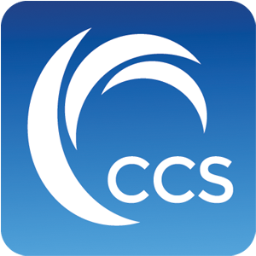

UNDERSTANDING LOSS MITIGATION
Unfortunately, purchasing a home in a volatile market can lead to unstable home values, which directly affect the amount of money you can receive for the home versus the amount needed to pay back what is owed according to your mortgage. Due to recent economic developments that have occurred in this country over the past six years, both the Federal Government and Lenders across the country have become aware of this problem, and have created avenues for borrowers under financial distress to negotiate a way for the borrower to either restructure their payments through loan modification, or to liquidate and sell the property to a willing buyer at market value, which is referred to as a “Short Sale”.

Christopher J. Gertz, Esq.
Complete Closing Solutions, LLC
888 South Andrews Avenue, Suite 204
Fort Lauderdale, FL 33316
Ph: (954) 565 - 2601
Fax: (954) 565 - 2602
Cell: (954) 547 – 7044
Chris@CompleteClosingSolutions.com
www.CompleteClosingSolutions.com

